2015 Advertising Rates and Information
NWO Golf Links is a monthly digital magazine, launching in January 2015, with delivery to over 20,000 email addresses in Northwest Ohio and Southern Michigan. We will receive additional exposure from a link on the Toledo Free Press digital edition which receives over 100,000 page views/month. NWO Golf Links will also be available via an app.
Distribution: A new issue will be released on the second Wednesday of every month.
Advertising Requirements:
Full page ad: 8 x 10.5
1/2 page ad: 8 x 5.25 or 10.5 x 4
1/4 page ad: 4 x 5.25 or 10.5 5 x 2
1/8 page ad: 4 x 2.625 or 2 x 5.25

Deadline: 25th of the preceding month

2015 Introductory Advertising Rates:
Size of ad: | 6 Mos. Commitment | 12 Mos. Commitment | 6 Month Prepay | One Year Prepay
Full Page | $200/mo. | $175/mo. | $1,100 | $1,925
Half Page | $150/mo. | $100/mo. | $825 | $1,100
1/4 Page | $75/mo. | $50/mo. | $412 | $550
1/8 Page | $50/mo. | $45/mo. | $275 | $495

Published by: , Back 9 Media Group
Contact: Fred Altvater, 419-344-3062, 6062 Wood Dr, Waterville, OH 43566
Page layout options:
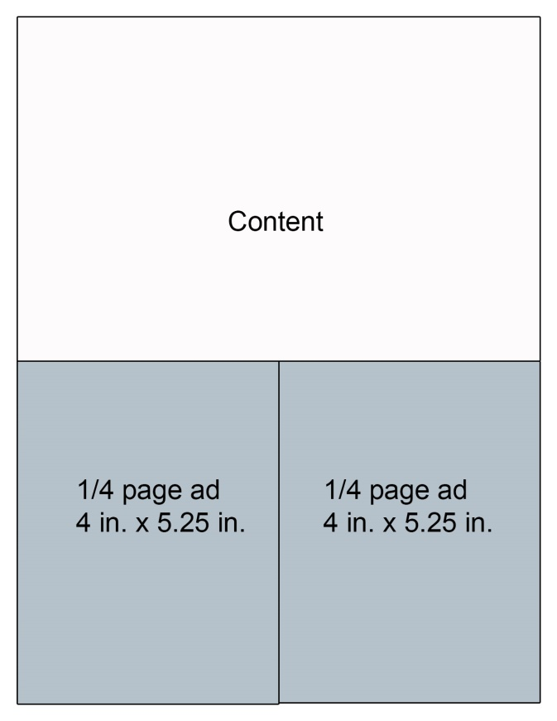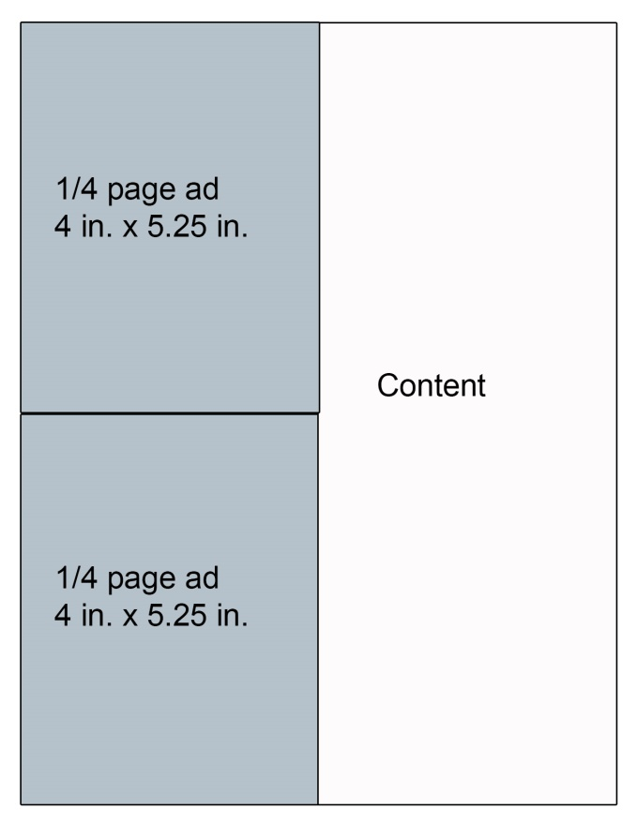
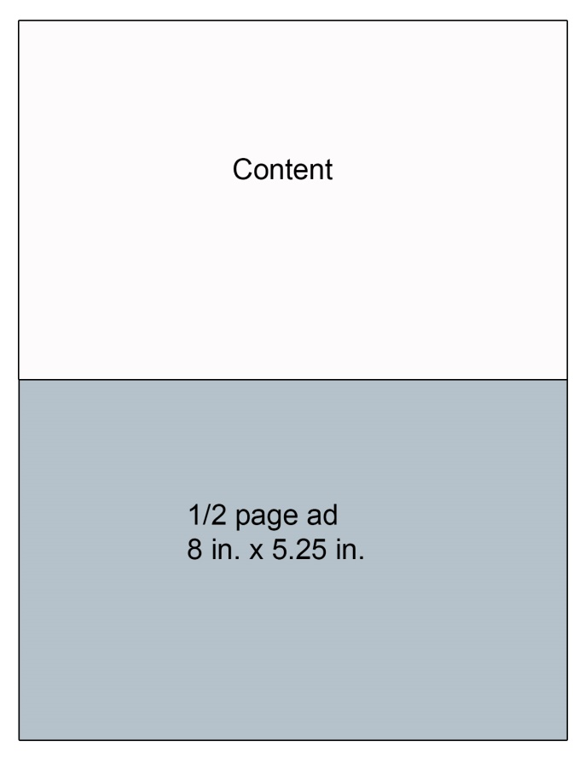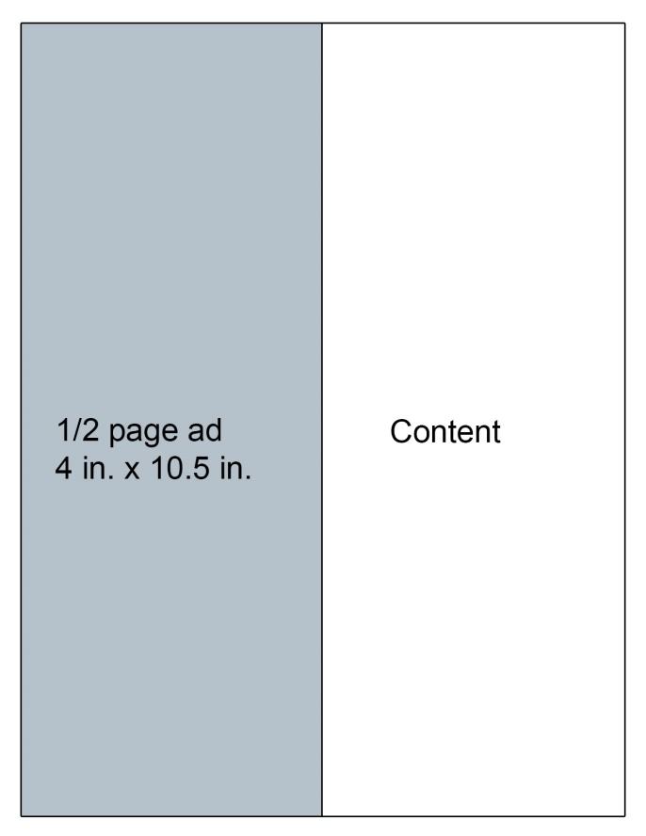

Advertiser Agreement
TERMS
- All rates are net to Back 9 Media Group
- 12 month prepay due upon agreement ; monthly payments are due on 25th of preceding month
- Fee based on receiving 150 dpi resolution ad artwork
- Any additional benefits received by either party must be outlined and agreed to in writing
- Oral agreements are not binding on either party
- Back 9 Media Group reserves the right to decline any advertising it deems unacceptable
ADVERTISER LEVEL: Choose level
Size of ad: | 6 Mos. Commitment | 12 Mos. Commitment | 6 Month Prepay | One Year PrePay
Full Page
Half Page
1/4 Page
1/8 Page

Billing Information:
Credit Card Number: _________________________________________
Exp Date: __________________ 3 Digit Code: _____________
Business Name: _________________________________________
Email Address: _______________________________________________
Billing Address:
Please return completed form to: Back 9 Media Group
Phone: 419-344-6613; fred@back9mediagroup.com
6062 Wood Dr.
Waterville, OH 43566
__________________________________________
__________________________________________
Phone: [ ] _____________________
Signature ___________________________________

